# Overview Pipeline

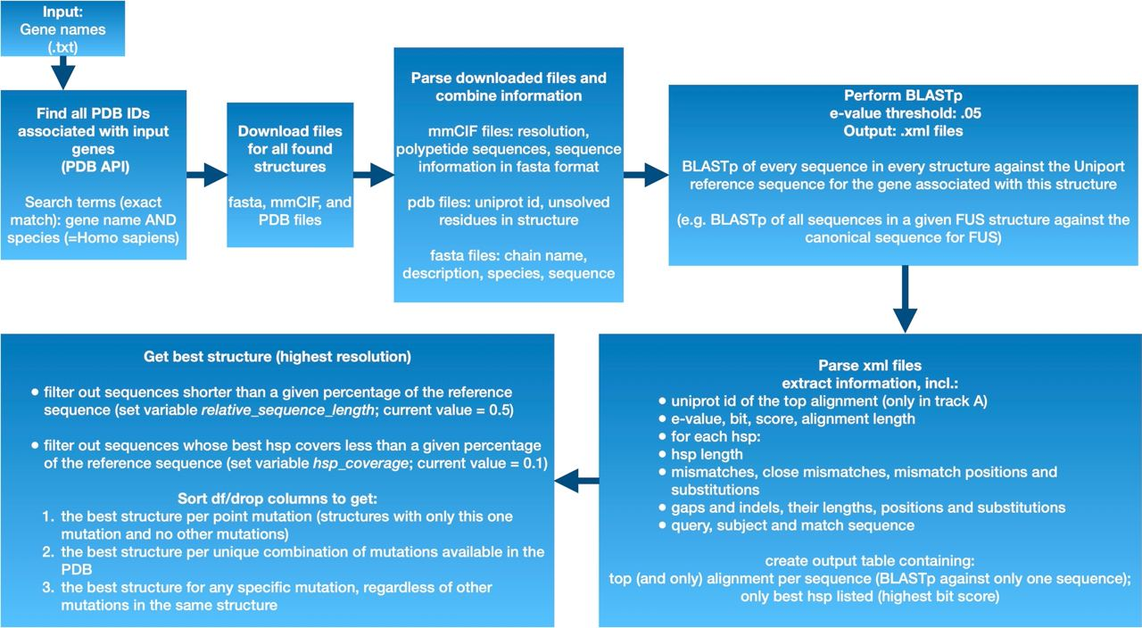

|  |  |  |  |
| --- | --- | --- | --- |
| Script name | Input | Operations | Output |
| *00_search_pdb.py* | * genes in .txt format  (e.g. SOD1 ALS2 FUS) | * Creates a folder called Results in the current working directory where all the output is going to be stored * searches the pdb for all structures associated with each gene name (in Homo Sapiens) | * ***directory: Results/*** * ***00_search_overview_PDBids.csv*** contains all gene names and corresponding PDB IDs if available |
| *01_download_files.py* | * ***00_search_overview_PDBids.csv*** | * creates a folder for each gene in the Results directory * downloads mmCIF, pdb, and fasta files for all structures into the respective gene folder | * ***directory per gene: Results/GENENAME/***   In each respective gene folder:   * ***mmCIF, pdb, and fasta files*** stored in format pdbID.cif/pdb/fasta   In the Results folder:   * ***01_search_overview_folders.csv*** lists all the the newly created folders and their contents * ***01_search_overview_n_structures.csv*** lists number of structures retrieved per gene |
| *02_parse_cif_files.py* | * ***01_search_overview_folders.csv*** | * Loops over all created folders and parses all mmCIf files, extracting:   + Resolution (999 for missing values/NMR structures)   + Polypeptide sequences (corresponds to sequences as shown in PyMOL)   + Fasta sequences | In each respective gene folder:   * ***_ex.fasta file*** for every structure  fasta file created from the mmCIF file * ***GENENAME_02_resolutions.csv*** contains the resolution for each structure associated with this gene * ***GENENAME_02_poly_seq.csv*** contains all polypeptide sequences for all structures associated with this gene   In the Results folder:   * ***02_all_resolutions.csv***  contains the resolutions of all parsed structures for all genes * ***02_all_poly_seq.csv***  contains all polypeptide sequences for all structures of all genes |
| *03_parse_fasta_files.py* | * ***01_search_overview_folders.csv*** | * Loops over folders containing fasta and _ex.fasta files * extracts info from fasta files, incl:   + chain name   + description   + species   + sequence * extracts info from _ex.fasta files, incl:   + chain name   + description   + uniprot id   + sequence * combines info from the two files | In each respective gene folder:   * ***GENENAME_05_fasta_info.csv***  contains information extracted from all fasta files for this gene * ***GENENAME_05_fasta_ex_info.csv***  contains information extracted from all _ex.fasta files for this gene * ***GENNAME_05_fasta_combined_info.csv*** contains combined information extracted from all fasta and _ex.fasta files for this gene   In the Results folder:   * ***05_fasta_info.csv***  contains information extracted from all fasta files for all genes * ***05_fasta_ex_info.csv***  contains information extracted from all _ex.fasta files for all genes * ***05_fasta_combined_info.csv***  contains combined information extracted from all fasta and _ex.fasta files for all genes |
| *04_blast_against_reference.py* | * ***05_fasta_combined_info.csv*** | * Creates a directory called RefSeqs in the Results directory * Loops over csv file  (one row for each unique sequence in all the pdb files for all genes) * downloads the reference sequence for the gene from uniprot into the RefSeqs directory * writes a fasta file for each unique sequence/chain in the df into the RefSeqs directory * performs BLASTp of all sequences against the reference sequence  (e.g. FUS canonical sequence for all sequences in all FUS structures) (output stored in .xml format in RefSeqs) * uses the blast output (xml files) to identify mismatches and add this information to the df | * **directory: Results/Refseqs**   In the RefSeqs folder:   * **reference sequence fasta files** in format GENE_reference.fasta * **unique sequences fasta files** in format GENE_pdbID_Chains.fasta * **BLASTp output files (.xml)** in format GENE_pdbID_Chains.xml   In the Results folder:  ***07_blast_two_sequences.csv*** lists all the information in the input file and the corresponding BLASTp results |
| *05_pdb_extract_unsolved_res.py* | * ***01_search_overview_folders.csv*** * ***06_blast_fasta.csv  OR 07_blast_two_sequences.csv*** | * Loops over folders and extracts info on missing residues / residues which have not been solved in the crystal structure from each pdb file * combines information on unsolved residues with info from 06_blast_fasta.csv / 08_blast_two_sequences.csv | In the Results folder:   * ***08_unsolved_residues_per_structure.csv*** lists all unsolved residues in all structures for all genes (one row for each structure) * ***08_unsolved_residues_per_chain.csv*** lists all unsolved residues in all chains of all structures for all genes (one row for each chain) * **08_all_info.csv**  contains all the information from *06_blast_fasta.csv* OR *07_blast_two_sequences.csv* plus on unsolved residues extracted from pdb files |
| *06_best_structure_per_mutation.py* | * ***08_all_info.csv*** * **02_all_resolutions.csv** | * combines the two dfs (according to PDBid) * filters out sequences shorter than a given percentage of the reference sequence (set variable *relative_sequence_length*) * filters out sequences whose best hsp covers less than a given percentage of the reference sequence (set variable *hsp_coverage*) * sort/filter the df to get:   + the best structure per point mutation (structures with only this one mutation and no other mutations)   + the best structure per unique combination of mutations available in the PDB   + the best structure for any specific mutation, regardless of other mutations in the same structure | In each respective gene folder:   * ***GENENAME_10_best_structure_per_point_mutation.csv*** lists best structure for each point mutation (one mutation per structure) in this gene * ***GENENAME_10_best_structure_all_unique_combinations.csv*** lists best structure for all unique mismatch combinations for this gene * ***GENENAME_10_best_structure_any_mutation.csv*** lists best structure for any mismatch in this gene regardless of other mismatches in this structure   In the Results folder:   * ***10_best_structure_per_point_mutation.csv*** lists best structure for each point mutation (one mutation per structure) in all genes * ***10_best_structure_all_unique_combinations.csv*** lists best structure for all unique mismatch combinations for all genes * ***10_best_structure_any_mutation.csv*** lists best structure for any mismatch for all genes regardless of other mismatches in this structure |
| *07_a_ClinVar_Annotations_edirect_per_gene_download_files.py* | * ***00_search_overview_availability.csv*** | * Query ClinVar for information on each gene of interest and download xml files with ids for all variants via edirect * parse xml files with ClinVar ids and download/retrieve .xml data from ClinVar for all variant ids associated with a gene | - all xml files downloaded from ClinVar are stored in the newly created ClinVar_Annotations folder (a subfolder in the Results directory) |
| *07_b_ClinVar_Annotations_edirect_per_gene_parse_files.py* | * ***00_search_overview_availability.csv*** | * parse xml files and create a df with ClinVar information for all variants for all input genes | - ***10_ClinVar_Annotations.csv***  contains ClinVar Annotations for all variants in all input genes |
| *08_add_ClinVar_Annotations_to_best_structures.py* | * ***09_best_structure_all_unique_combinations.csv*** * ***09_best_structure_any_mutation.csv*** * ***09_best_structure_per_point_mutation.csv*** * ***10_ClinVar_Annotations.csv*** | * adds availalable ClinVar annotations to all three best_structure tables | * ***11_best_structure_all_unique_combinations.csv***  lists best structure for all unique mismatch combinations for all genes (incl. ClinVar annotations) * ***11_best_structure_any_mutation.csv)*** lists best structure for any mismatch for all genes regardless of other mismatches in this structure(incl. ClinVar annotations * ***11_best_structure_per_point_mutation.csv*** lists best structure for each point mutation (one mutation per structure) in all genes (incl. ClinVar annotations) |